**OPEN SOURCE PROGRAMMING**

**CPAN 204 RNA**

**Pizza Project Manual**

**Akshar Solanki**

**N01418888**

November 04, 2021

**Table of Contents**

1. Access Home Page…………………………………………………………03
2. Enter Personal Details……………………………………………………05
3. Make Selection For Pizza…………………………………………..….07
4. Order Confirmation……………………………………....................09

**01** **Access Home Page**



To access the home page of the Pizza ordering web application, one must go on a web browser. In the search box of the web browser type the address the web application: *localhost/pizzaproject/home.php*. After entering the url on pressing enter, browser opens the home page of the app. Once home page is accessed, the user sees various options to be filled.

Pizza application home page:

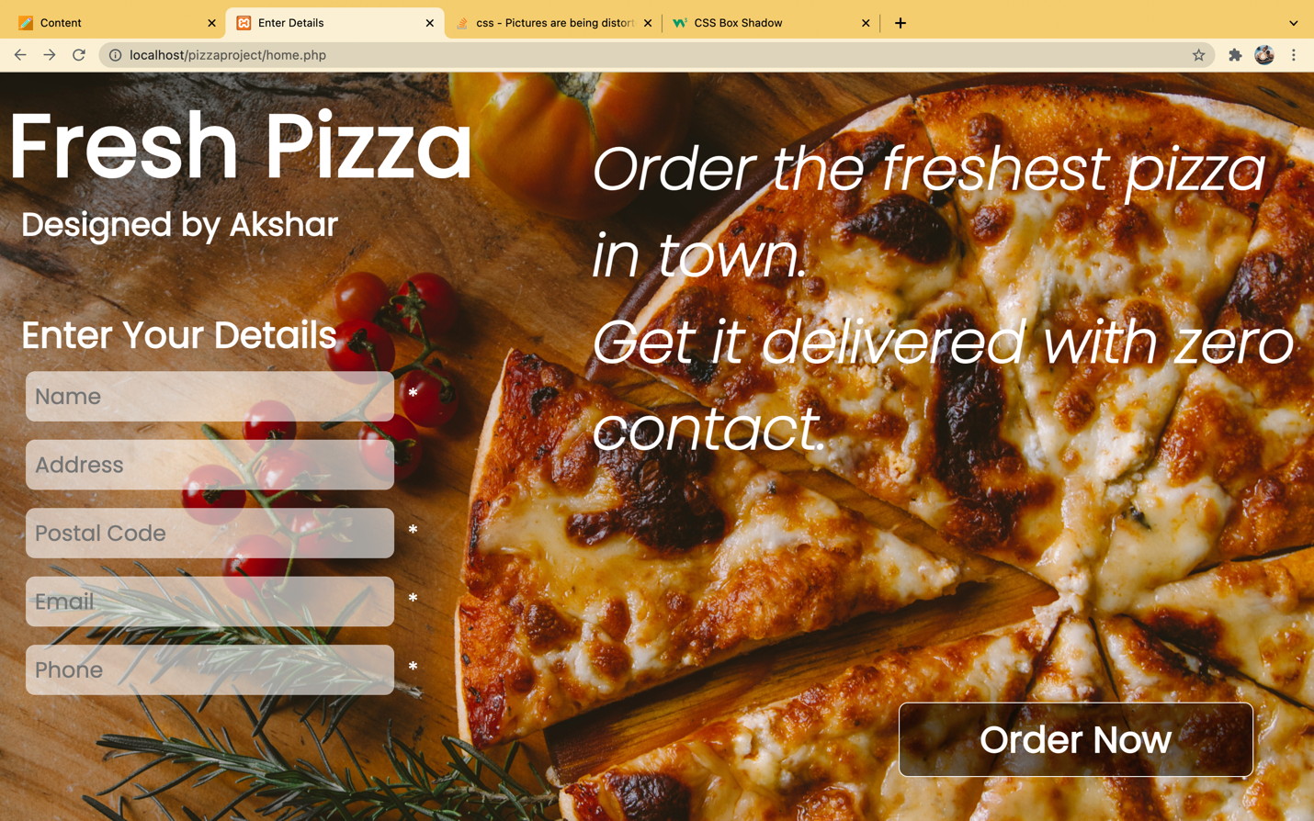

……………………………………………………………………

**02** **Enter Personal Details**

On the home page, user has to enter details about various required fields. The first textbox lets the user enter their first name and lastname. The second field lets the user enter their address which will be used to deliver their order. The third textbox lets the user enter the postal code of the address. The fourth fields gather detail about the user’s email address. This will be used in the future for promotion codes and coupons. The final textbox allows user to enter their phone number.

All the details are required to be entered except address. If a user does not enter required input fields the application shows a error messages specific to the field.

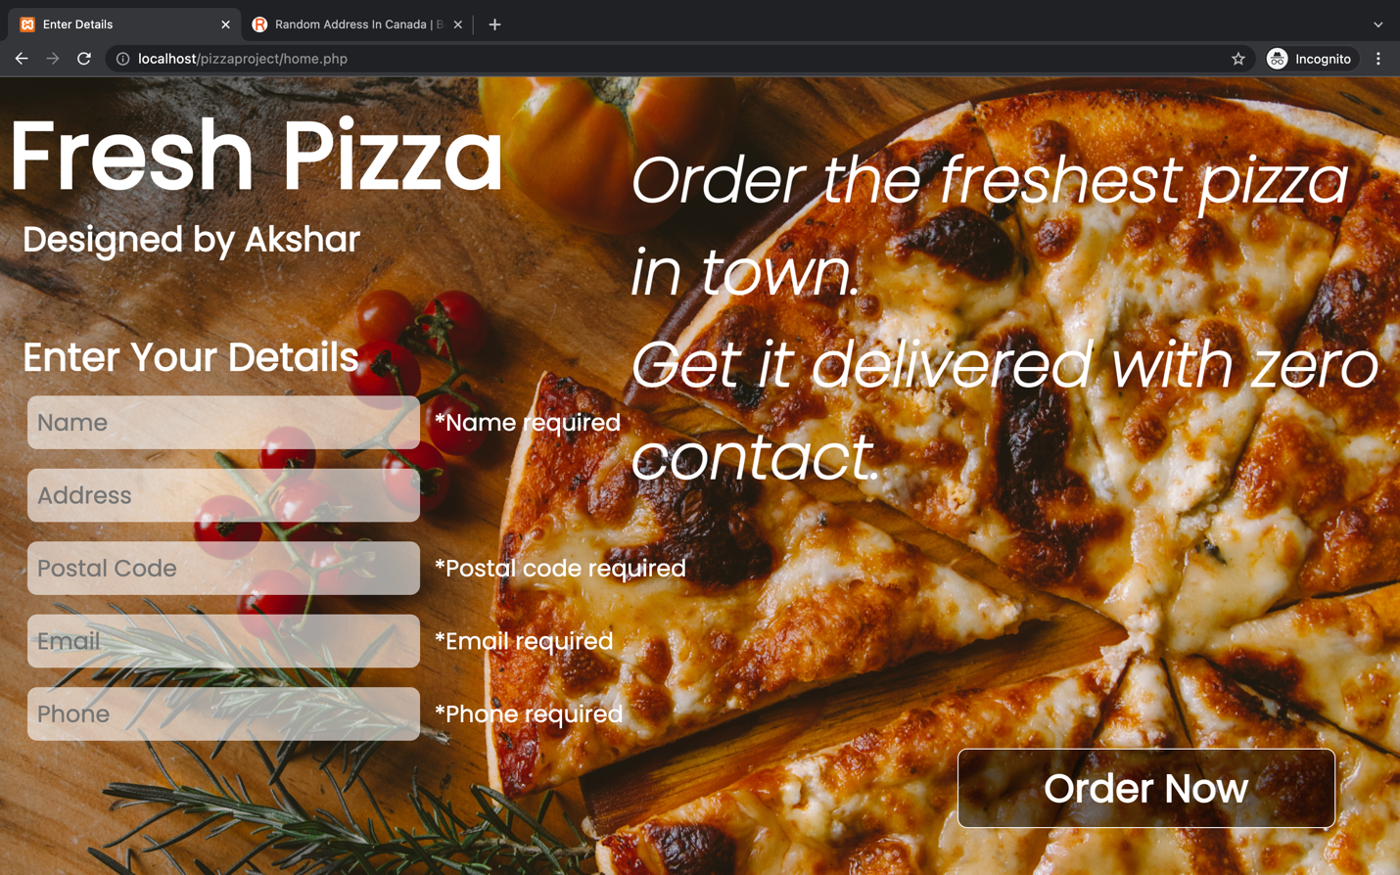

Once the users has entered all the personal details, the user can proceed to order the pizza. Note: the personal details are kept confidential within the database. So users can relax and not worry about their data getting stolen.

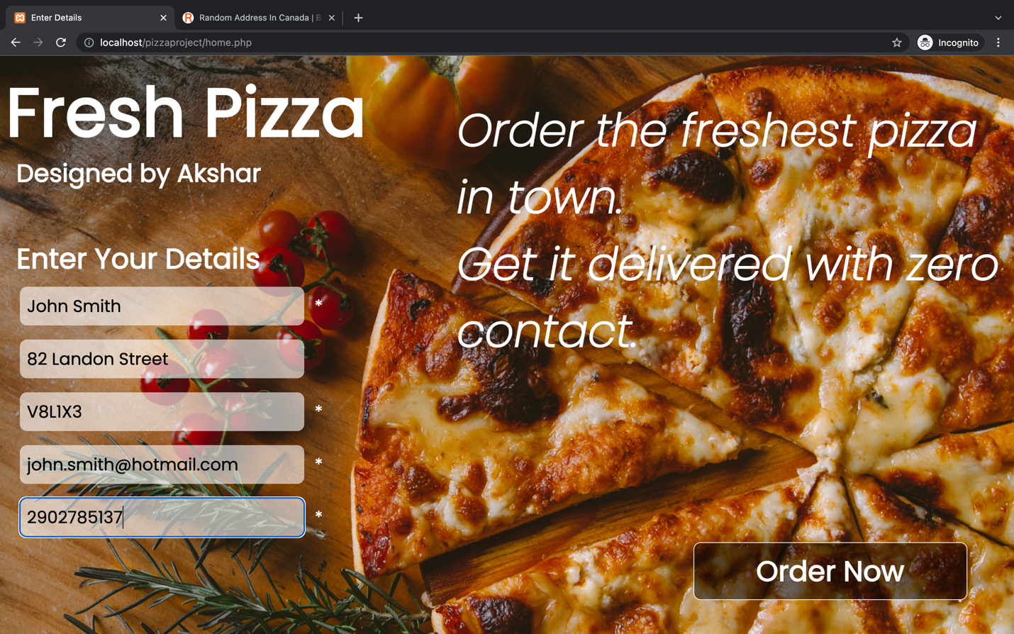

……………………………………………………………………

**03** **Make Selection for Pizza**

Upon successful entering of data the user must click on order now button at the bottom left corner of the page. Upon click the order now button the user has the options to customize their liking.

The user can select size of the pizza they need and the type of pizza. The application delivers three sizes of pizza: small, medium, and large. There 5 types of pizza available: Pepperoni, Hawaiian, cheese, meat lovers and vegetarian.

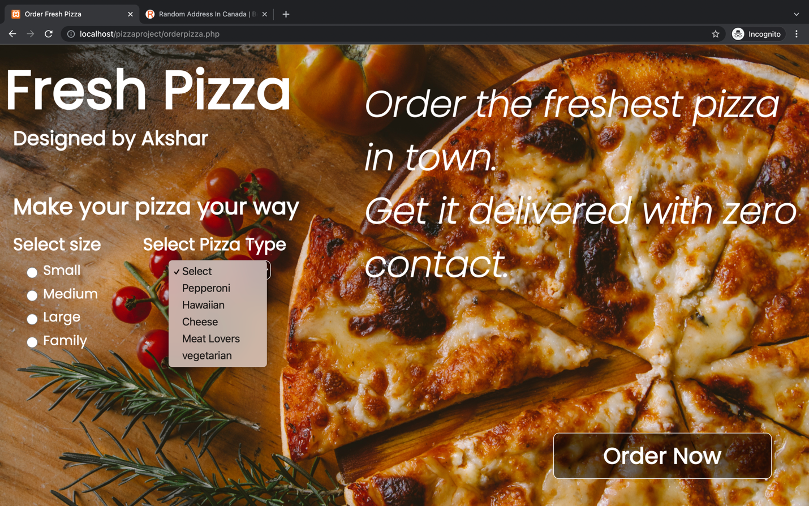

Note: It is essential that user selects one size and one type of toppings for the pizza. If the size or toppings are missing, the order shall not be taken.

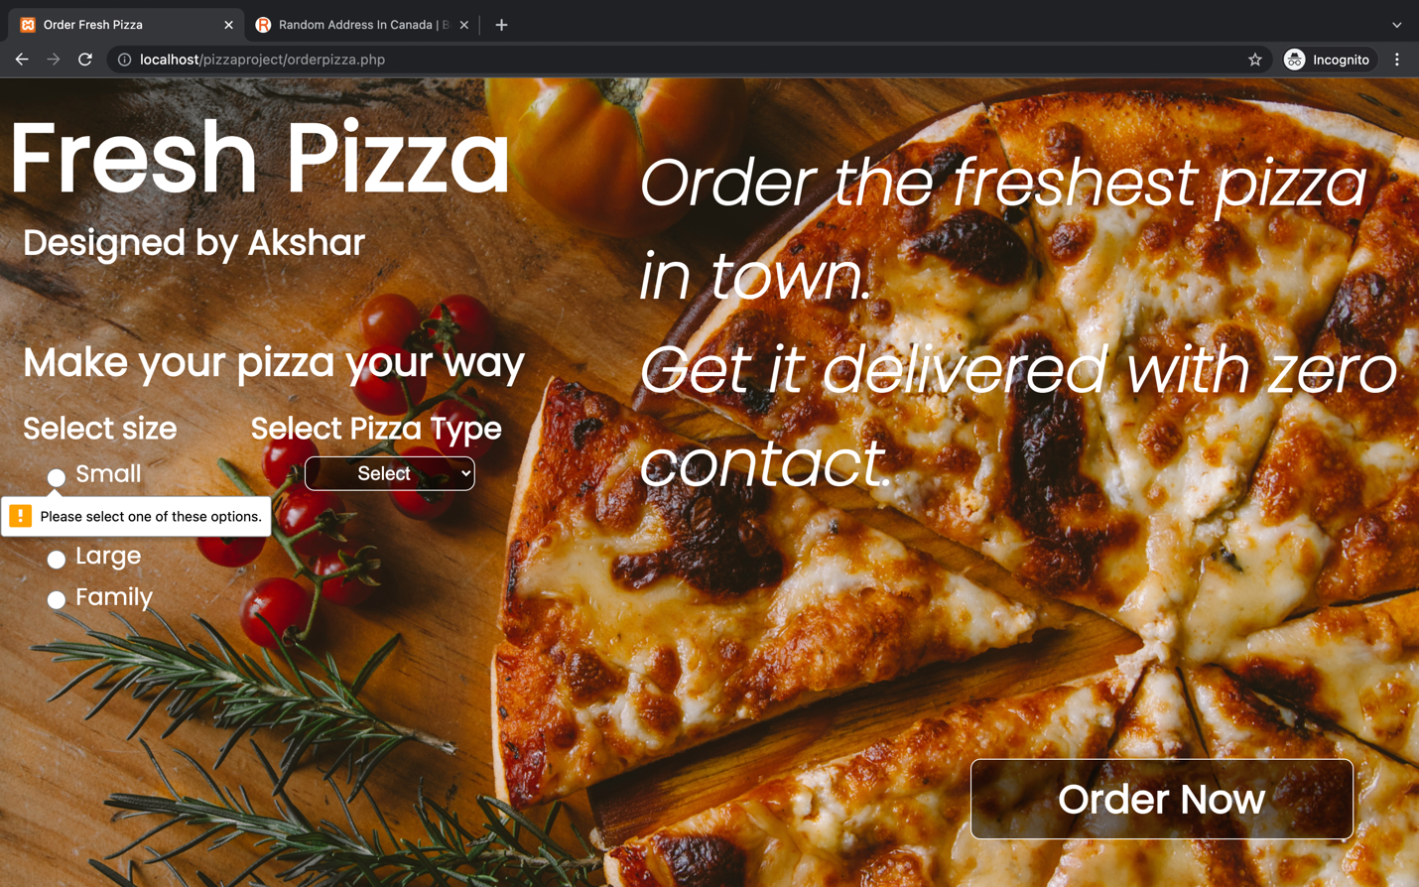

Once the user creates selection for the pizza, the order now button should be clicked. It summarizes and confirm the order.

……………………………………………………………………

**03** **Order Confirmation**

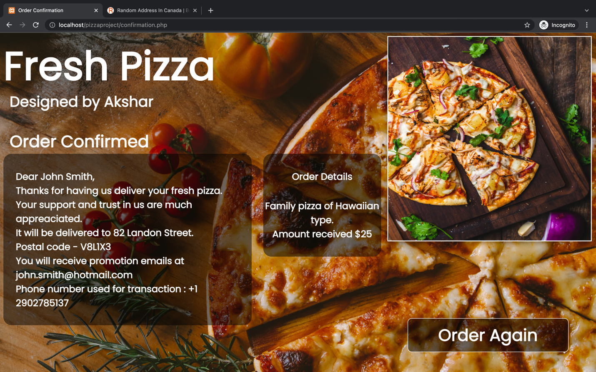

The order will be summarized the system once the pizza is customized. The confirmation page is displayed to let the user know that the order is being prepared. The confirmation page shows customer name, address to which pizza will be delivered with postal code, and the phone number of the customer.

Along with customer details the page will display order details which includes the size, type, and the total amount paid for the pizza.

The web application also will show a different page with the image of the toppings the user has selected. For instance if the user has selected Hawaiian pizza, the web page will display an image of Hawaiian pizza.

total price of the pizza is calculated using the given chart below.

|  |  |  |  |  |  |
| --- | --- | --- | --- | --- | --- |
| **Size/Type** | **Pepperoni** | **Hawaiian** | **Cheese** | **Meat lovers** | **Vegetarian** |
| **Small** | **$10** | **$10** | **$7** | **$20** | **$8** |
| **Medium** | **$18** | **$15** | **$10** | **$25** | **$14** |
| **Large** | **$25** | **$22** | **$15** | **$30** | **$18** |
| **Family** | **$30** | **$27** | **$20** | **$35** | **$23** |

The user can also place a new order using the order again button.

…….…..………..….……End..Of..Report………..………..….